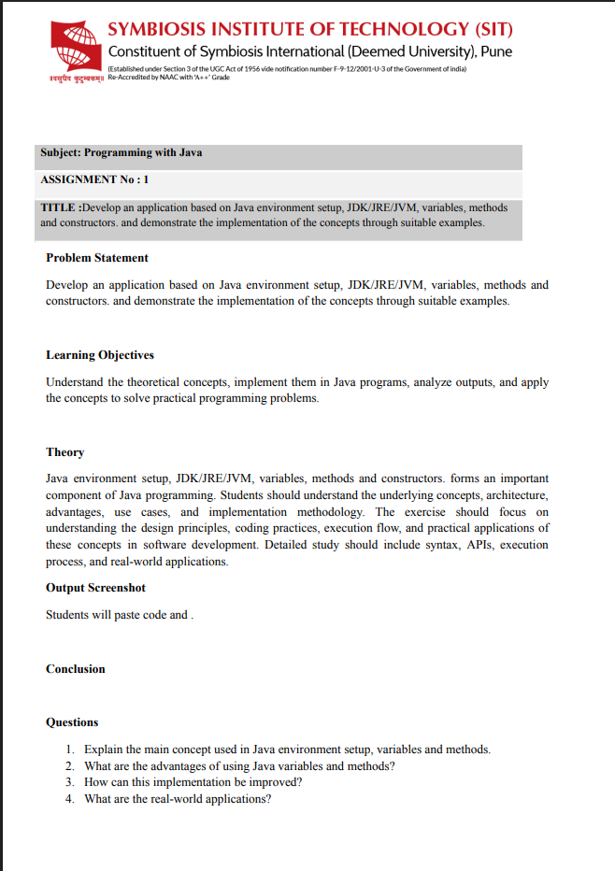

ASSIGNMENT NO.1
Akshit Gawade - 25070122029
TITLE: Develop an application based on Java environment setup, JDK/JRE/JVM, variables, methods and constructors. and demonstrate the implementation of the concepts through suitable examples.
Problem Statement: Develop an application based on Java environment setup, JDK/JRE/JVM, variables, methods and constructors. and demonstrate the implementation of the concepts through suitable examples.
Learning Objectives: Understand the theoretical concepts, implement them in Java programs, analyze outputs, and apply the concepts to solve practical programming problems.
Theory:
Java environment setup, JDK/JRE/JVM, variables, methods and constructors. forms an important component of Java programming. Students should understand the underlying concepts, architecture, advantages, use cases, and implementation methodology. The exercise should focus on understanding the design principles, coding practices, execution flow, and practical applications of these concepts in software development. Detailed study should include syntax, APIs, execution process, and real-world applications.
JDK (Java Development Kit): A software package used to develop, compile, debug, and run Java applications. It includes the JRE, compiler (javac), debugger, and other development tools.
JRE (Java Runtime Environment): A software package required to run Java programs on a computer. It contains the JVM and the libraries needed to execute Java applications but does not include development tools.
JVM (Java Virtual Machine): The JVM is the virtual machine that executes Java bytecode and allows Java programs to run on any operating system. It manages memory, converts bytecode into machine code, and provides platform independence.
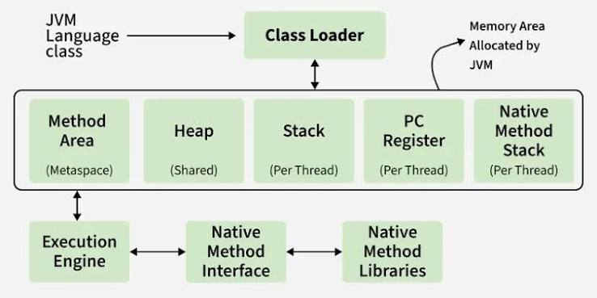
The Class Loader loads Java class files into the JVM, and the JVM allocates memory into the Method Area, Heap, Stack, PC Register, and Native Method Stack to store and execute the program. The Execution Engine runs the bytecode, while the Native Method Interface (JNI) connects the JVM to Native Method Libraries to execute platform-specific code when needed.
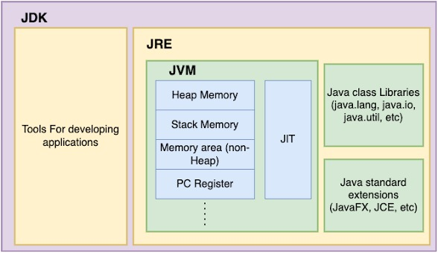
The image shows that the JDK contains the JRE, and the JRE contains the JVM, meaning the JDK is used to develop Java programs while the JRE runs them. Inside the JVM, memory (Heap, Stack, PC Register, etc.) and the JIT Compiler execute Java programs, while Java libraries and standard extensions provide the built-in functionality needed by applications.
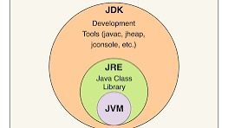
The image shows that the JDK is the complete package for developing Java applications, containing the JRE, which in turn contains the JVM. In simple terms: JDK = Development + Execution tools, JRE = Libraries to run Java programs, and JVM = Engine that executes Java bytecode.
Conclusion:
This assignment helped in understanding the Java programming environment, including the roles of JDK, JRE, and JVM, and how they work together to develop and run Java applications
Questions:
- Explain the main concept used in Java environment setup, variables and methods.
Ans. Java environment setup involves installing the JDK and configuring the system to compile and run Java programs. Variables store data, while methods are reusable blocks of code that perform specific tasks and improve program organization.
- What are the real-world applications?
Ans. Java is widely used in developing web applications, Android mobile apps, enterprise software, and desktop applications. It is also used in banking systems, cloud computing, and big data technologies due to its platform independence and reliability.

